**UNIT-I**

**OVERVIEW OF AI**

**Define AI**

Artificial Intelligence is composed of two words **Artificial** and **Intelligence**, where Artificial defines *"man-made,"* and intelligence defines *"thinking power"*, hence AI means *"a man-made thinking power."*

So, we can define AI as:

 "It is a branch of computer science by which we can create intelligent machines which can behave like a human, think like humans, and able to make decisions."

Artificial Intelligence exists when a machine can have human based skills such as learning, reasoning, and solving problems

With Artificial Intelligence you do not need to preprogram a machine to do some work, despite that you can create a machine with programmed algorithms which can work with own intelligence, and that is the awesomeness of AI.

It is believed that AI is not a new technology, and some people says that as per Greek myth, there were Mechanical men in early days which can work and behave like humans.

Goals of Artificial Intelligence

Following are the main goals of Artificial Intelligence:

1. Replicate human intelligence
2. Solve Knowledge-intensive tasks
3. An intelligent connection of perception and action
4. Building a machine which can perform tasks that requires human intelligence such as:
   * Proving a theorem
   * Playing chess
   * Plan some surgical operation
   * Driving a car in traffic
5. Creating some system which can exhibit intelligent behavior, learn new things by itself, demonstrate, explain, and can advise to its user.

What Comprises to Artificial Intelligence?

Artificial Intelligence is not just a part of computer science even it's so vast and requires lots of other factors which can contribute to it. To create the AI first we should know that how intelligence is composed, so the Intelligence is an intangible part of our brain which is a combination of Reasoning, learning, problem-solving perception, language understanding, etc.

To achieve the above factors for a machine or software Artificial Intelligence requires the following discipline:

* Mathematics
* Biology
* Psychology
* Sociology
* Computer Science
* Neurons Study
* Statistics

Advantages of Artificial Intelligence

Following are some main advantages of Artificial Intelligence:

* High Accuracy with less errors: AI machines or systems are prone to less errors and high accuracy as it takes decisions as per pre-experience or information.
* High-Speed: AI systems can be of very high-speed and fast-decision making, because of that AI systems can beat a chess champion in the Chess game.
* High reliability: AI machines are highly reliable and can perform the same action multiple times with high accuracy.
* Useful for risky areas: AI machines can be helpful in situations such as defusing a bomb, exploring the ocean floor, where to employ a human can be risky.
* Digital Assistant: AI can be very useful to provide digital assistant to the users such as AI technology is currently used by various E-commerce websites to show the products as per customer requirement.
* Useful as a public utility: AI can be very useful for public utilities such as a self-driving car which can make our journey safer and hassle-free, facial recognition for security purpose, Natural language processing to communicate with the human in human-language, etc.

Disadvantages of Artificial Intelligence

Every technology has some disadvantages, and thesame goes for Artificial intelligence. Being so advantageous technology still, it has some disadvantages which we need to keep in our mind while creating an AI system. Following are the disadvantages of AI:

* High Cost: The hardware and software requirement of AI is very costly as it requires lots of maintenance to meet current world requirements.
* Can't think out of the box: Even we are making smarter machines with AI, but still they cannot work out of the box, as the robot will only do that work for which they are trained, or programmed.
* No feelings and emotions: AI machines can be an outstanding performer, but still it does not have the feeling so it cannot make any kind of emotional attachment with human, and may sometime be harmful for users if the proper care is not taken.
* Increase dependency on machines: With the increment of technology, people are getting more dependent on devices and hence they are losing their mental capabilities.
* No Original Creativity: As humans are so creative and can imagine some new ideas but still AI machines cannot beat this power of human intelligence and cannot be creative and imaginative.

## Maturation of Artificial Intelligence (1943-1952)

* **Year 1943:** The first work which is now recognized as AI was done by Warren McCulloch and Walter pits in 1943. They proposed a model of **artificial neurons**.
* **Year 1949:** Donald Hebb demonstrated an updating rule for modifying the connection strength between neurons. His rule is now called **Hebbian learning**.
* **Year 1950:** The Alan Turing who was an English mathematician and pioneered Machine learning in 1950. Alan Turing publishes **"Computing Machinery and Intelligence"** in which he proposed a test. The test can check the machine's ability to exhibit intelligent behavior equivalent to human intelligence, called a **Turing test**.

## The birth of Artificial Intelligence (1952-1956)

* **Year 1955:** An Allen Newell and Herbert A. Simon created the "first artificial intelligence program"Which was named as **"Logic Theorist"**. This program had proved 38 of 52 Mathematics theorems, and find new and more elegant proofs for some theorems.
* **Year 1956:** The word "Artificial Intelligence" first adopted by American Computer scientist John McCarthy at the Dartmouth Conference. For the first time, AI coined as an academic field.

At that time high-level computer languages such as FORTRAN, LISP, or COBOL were invented. And the enthusiasm for AI was very high at that time.

## The golden years-Early enthusiasm (1956-1974)

* **Year 1966:** The researchers emphasized developing algorithms which can solve mathematical problems. Joseph Weizenbaum created the first chatbot in 1966, which was named as ELIZA.
* **Year 1972:** The first intelligent humanoid robot was built in Japan which was named as WABOT-1.

## The first AI winter (1974-1980)

* The duration between years 1974 to 1980 was the first AI winter duration. AI winter refers to the time period where computer scientist dealt with a severe shortage of funding from government for AI researches.
* During AI winters, an interest of publicity on artificial intelligence was decreased.

A boom of AI (1980-1987)

* **Year 1980:** After AI winter duration, AI came back with "Expert System". Expert systems were programmed that emulate the decision-making ability of a human expert.
* In the Year 1980, the first national conference of the American Association of Artificial Intelligence **was held at Stanford University**.

## The second AI winter (1987-1993)

* The duration between the years 1987 to 1993 was the second AI Winter duration.
* Again Investors and government stopped in funding for AI research as due to high cost but not efficient result. The expert system such as XCON was very cost effective.

## The emergence of intelligent agents (1993-2011)

* **Year 1997:** In the year 1997, IBM Deep Blue beats world chess champion, Gary Kasparov, and became the first computer to beat a world chess champion.
* **Year 2002:** for the first time, AI entered the home in the form of Roomba, a vacuum cleaner.
* **Year 2006:** AI came in the Business world till the year 2006. Companies like Facebook, Twitter, and Netflix also started using AI.

## Deep learning, big data and artificial general intelligence (2011-present)

* **Year 2011:** In the year 2011, IBM's Watson won jeopardy, a quiz show, where it had to solve the complex questions as well as riddles. Watson had proved that it could understand natural language and can solve tricky questions quickly.
* **Year 2012:** Google has launched an Android app feature "Google now", which was able to provide information to the user as a prediction.
* **Year 2014:** In the year 2014, Chatbot "Eugene Goostman" won a competition in the infamous "Turing test."
* **Year 2018:** The "Project Debater" from IBM debated on complex topics with two master debaters and also performed extremely well.
* Google has demonstrated an AI program "Duplex" which was a virtual assistant and which had taken hairdresser appointment on call, and lady on other side didn't notice that she was talking with the machine.

Now AI has developed to a remarkable level. The concept of Deep learning, big data, and data science are now trending like a boom. Nowadays companies like Google, Facebook, IBM, and Amazon are working with AI and creating amazing devices. The future of Artificial Intelligence is inspiring and will come with high intelligence.

# Types of Artificial Intelligence:

Artificial Intelligence can be divided in various types, there are mainly two types of main categorization which are based on capabilities and based on functionally of AI. Following is flow diagram which explain the types of AI.

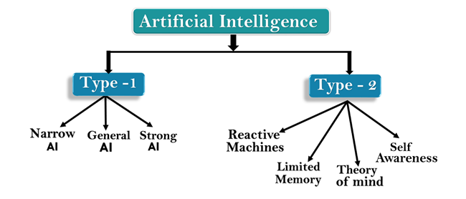

AI type-1: Based on Capabilities

1. Weak AI or Narrow AI:

Narrow AI is a type of AI which is able to perform a dedicated task with intelligence.The most common and currently available AI is Narrow AI in the world of Artificial Intelligence.

Narrow AI cannot perform beyond its field or limitations, as it is only trained for one specific task. Hence it is also termed as weak AI. Narrow AI can fail in unpredictable ways if it goes beyond its limits.

Apple Siriis a good example of Narrow AI, but it operates with a limited pre-defined range of functions.

IBM's Watson supercomputer also comes under Narrow AI, as it uses an Expert system approach combined with Machine learning and natural language processing.

Some Examples of Narrow AI are playing chess, purchasing suggestions on e-commerce site, self-driving cars, speech recognition, and image recognition.

2. General AI:

General AI is a type of intelligence which could perform any intellectual task with efficiency like a human.

The idea behind the general AI to make such a system which could be smarter and think like a human by its own.

Currently, there is no such system exist which could come under general AI and can perform any task as perfect as a human.

The worldwide researchers are now focused on developing machines with General AI.

As systems with general AI are still under research, and it will take lots of efforts and time to develop such systems.

3. Super AI:

Super AI is a level of Intelligence of Systems at which machines could surpass human intelligence, and can perform any task better than human with cognitive properties. It is an outcome of general AI.

Some key characteristics of strong AI include capability include the ability to think, to reason, solve the puzzle, make judgments, plan, learn, and communicate by its own.

Super AI is still a hypothetical concept

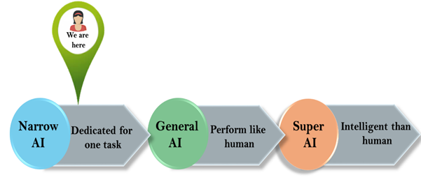

## Artificial Intelligence type-2: Based on functionality

### 1. Reactive Machines

* Purely reactive machines are the most basic types of Artificial Intelligence.
* Such AI systems do not store memories or past experiences for future actions.
* These machines only focus on current scenarios and react on it as per possible best action.
* IBM's Deep Blue system is an example of reactive machines.
* Google's AlphaGo is also an example of reactive machines.

### 2. Limited Memory

* Limited memory machines can store past experiences or some data for a short period of time.
* These machines can use stored data for a limited time period only.
* Self-driving cars are one of the best examples of Limited Memory systems. These cars can store recent speed of nearby cars, the distance of other cars, speed limit, and other information to navigate the road.

### 3. Theory of Mind

* Theory of Mind AI should understand the human emotions, people, beliefs, and be able to interact socially like humans.
* This type of AI machines are still not developed, but researchers are making lots of efforts and improvement for developing such AI machines.

### 4. Self-Awareness

* Self-awareness AI is the future of Artificial Intelligence. These machines will be super intelligent, and will have their own consciousness, sentiments, and self-awareness.
* These machines will be smarter than human mind.
* Self-Awareness AI does not exist in reality still and it is a hypothetical concept.

**AI Techniques:**

To solve the problem AI generally uses the following techniques:

* **Search** (Eg Chess Game, tic tac toe)
* **Pattern Recognition** ( A vision program may try to match retina of an eye, language text, etc.)
* **Representation** (To represent world *facts usually use mathematical logics)*
* **Inference** (From some Facts other can be inferred)
* **Common Sense Knowledge and Reasoning**
* **Learning from Experience** (ML)
* **Planning** (Sequence of actions)
* **Heuristics** (It is a way of trying to discover something or embedded in program)
* **Genetic Programming** (Survival of the fittest using LISP)
* **Epistemology** (Branch of philosophy related to study of nature, origin and limits of human knowledge)

**Programming Languages of AI:**

The language which can provide the symbolic notations can be used.

* **LISP** ( LISt Processing) developed by John Mccarthy in 1958**.**
* **PROLOG** (PROgramming in LOGic) developed by Alain colmerauer in 1970s
* **C** was also used.
* Now a days **Python** is used for the work of AI and ML.

**Fields of AI**

The major fields of AI are:

* Machine Learning,
* Neural Networks,
* Vision,
* Robotics,
* Expert Systems,
* Speech Processing,
* Natural Language Processing, and
* Planning,
* Game Playing and
* Intelligent Tutor

1. **INTRODUCTION TO AI PROBLEMS**
2. To solve the problem of building a system you should take the following steps:
3. 1. Define the problem accurately including detailed specifications and what constitutes a
4. suitable solution.
5. 2. Scrutinize the problem carefully, for some features may have a central affect on the
6. chosen method of solution.
7. 3. Segregate and represent the background knowledge needed in the solution of the
8. problem.
9. 4. Choose the best solving techniques for the problem to solve a solution.
10. To solve the problem of building a system you should take the following steps:
11. 1. Define the problem accurately including detailed specifications and what constitutes a
12. suitable solution.
13. 2. Scrutinize the problem carefully, for some features may have a central affect on the
14. chosen method of solution.
15. 3. Segregate and represent the background knowledge needed in the solution of the
16. problem.
17. 4. Choose the best solving techniques for the problem to solve a solution.

To solve the problem of building a system we should take following steps:

* **Define the problem precisely** (initial state and final state)
* **Analyze the problem** (as some features may have a central effect on chosen method of solution)
* **Isolate and represent the task knowledge that is necessary to solve the problem**
* **Abstract problem converted to real workable state** (Abstraction {super category having common features})
* **Apply AI techniques** (Choose the best problem solving technique(s) and apply it to particular problem)
* **Degree of Independence** (some degree of independence between ***problems and problem solving techniques*** {AI problem without AI techniques and non AI problem. Goal is to make independent program.})

1. **Problem solving** is a process of generating solutions from observed data.

* A *problem* is characterized by a set of goals.
* A set of *objects* and
* A set of *operations*.

These could be ill defined and may evolve during problem solving.

**II. PRODUCTION SYSTEM**

Problem solving is a process of generating solutions from observed data.

is characterized by a set of goals,

objects, and

operations.

These could be ill-defined and may evolve during problem solving.

problem space is an abstract space.

A problem space encompasses all valid states that can be generated by the

application of any combination of operators on any combination of objects.

The problem space may contain one or more solutions. A solution is a

combination of operations and objects that achieve the goals.

search to the search for a solution in a problem space.

search control strategies

The depth-first search and breadth-first search are the two common search

strategies

Problem solving is a process of generating solutions from observed data.

is characterized by a set of goals,

objects, and

operations.

These could be ill-defined and may evolve during problem solving.

problem space is an abstract space.

A problem space encompasses all valid states that can be generated by the

application of any combination of operators on any combination of objects.

The problem space may contain one or more solutions. A solution is a

combination of operations and objects that achieve the goals.

search to the search for a solution in a problem space.

search control strategies

The depth-first search and breadth-first search are the two common search

strategies

Problem solving is a process of generating solutions from observed data.

is characterized by a set of goals,

objects, and

operations.

These could be ill-defined and may evolve during problem solving.

problem space is an abstract space.

A problem space encompasses all valid states that can be generated by the

application of any combination of operators on any combination of objects.

The problem space may contain one or more solutions. A solution is a

combination of operations and objects that achieve the goals.

search to the search for a solution in a problem space.

search control strategies

The depth-first search and breadth-first search are the two common search

strategies

Problem solving is a process of generating solutions from observed data.

is characterized by a set of goals,

objects, and

operations.

These could be ill-defined and may evolve during problem solving.

problem space is an abstract space.

A problem space encompasses all valid states that can be generated by the

application of any combination of operators on any combination of objects.

The problem space may contain one or more solutions. A solution is a

combination of operations and objects that achieve the goals.

search to the search for a solution in a problem space.

search control strategies

The depth-first search and breadth-first search are the two common search

strategies

Problem solving is a process of generating solutions from observed data.

is characterized by a set of goals,

objects, and

operations.

These could be ill-defined and may evolve during problem solving.

problem space is an abstract space.

A problem space encompasses all valid states that can be generated by the

application of any combination of operators on any combination of objects.

The problem space may contain one or more solutions. A solution is a

combination of operations and objects that achieve the goals.

search to the search for a solution in a problem space.

search control strategies

The depth-first search and breadth-first search are the two common search

strategies

Problem solving is a process of generating solutions from observed data.

is characterized by a set of goals,

objects, and

operations.

These could be ill-defined and may evolve during problem solving.

problem space is an abstract space.

A problem space encompasses all valid states that can be generated by the

application of any combination of operators on any combination of objects.

The problem space may contain one or more solutions. A solution is a

combination of operations and objects that achieve the goals.

search to the search for a solution in a problem space.

search control strategies

The depth-first search and breadth-first search are the two common search

strategies

Problem solving is a process of generating solutions from observed data.

is characterized by a set of goals,

objects, and

operations.

These could be ill-defined and may evolve during problem solving.

problem space is an abstract space.

A problem space encompasses all valid states that can be generated by the

application of any combination of operators on any combination of objects.

The problem space may contain one or more solutions. A solution is a

combination of operations and objects that achieve the goals.

search to the search for a solution in a problem space.

search control strategies

The depth-first search and breadth-first search are the two common search

strategies

Problem solving is a process of generating solutions from observed data.

is characterized by a set of goals,

objects, and

operations.

These could be ill-defined and may evolve during problem solving.

problem space is an abstract space.

A problem space encompasses all valid states that can be generated by the

application of any combination of operators on any combination of objects.

The problem space may contain one or more solutions. A solution is a

combination of operations and objects that achieve the goals.

search to the search for a solution in a problem space.

search control strategies

The depth-first search and breadth-first search are the two common search

strategies

Problem solving is a process of generating solutions from observed data.

is characterized by a set of goals,

objects, and

operations.

These could be ill-defined and may evolve during problem solving.

problem space is an abstract space.

A problem space encompasses all valid states that can be generated by the

application of any combination of operators on any combination of objects.

The problem space may contain one or more solutions. A solution is a

combination of operations and objects that achieve the goals.

search to the search for a solution in a problem space.

search control strategies

The depth-first search and breadth-first search are the two common search

strategies

Production systems are important in AI because they enhance the creation of AI-based programs and the automation of machines. They also enhance the fast and accurate resolution of conflicts in automated processes through the use of **IF-THEN** conditions. The set of rules in a production system in **Artificial Intelligence defines** the behavior of the machine. It helps the machine respond to the surroundings.

*A production system in AI is a type of cognitive architecture that defines specific actions as per certain rules. The rules represent the declarative knowledge of a machine to respond according to different conditions.* Today, many expert systems and automation methodologies rely on the rules of production systems.

**1) Production System Components**

A production system consists of three main components:

* A global database,
* A set of rules, and
* A control system.

The brief description is as follow:

1. **Global database**

This contains the architecture of the production system and acts as a *central data structure*. All the information and data used in the execution of tasks is stored in this *database*. The production rules of the system operate here. Eg: chess

There are two types of global databases: *temporary and permanent*. The temporary global database consists of short-term actions that are based on circumstances. In a permanent global database, there are fixed actions that cannot be altered.

1. **Production Rules**

The data gathered from the global database applies some rules within the production system. These rules are called the *production rules*. They are conditional **if-then** branches. The global database checks these conditions so that the rules can be applied.

If a particular pre-condition is accepted by the central data structure, the rule will be executed. In this case, the central data structure will adjust accordingly. If the global database does not accept the pre-condition, no action is taken. In this case, the database doesn’t change.Eg: solving puzzle

1. **A Control System**

The *application of rules* in the system is examined by the control system. When a pre-condition is accepted by the global database, the control system decides the rule that needs to be applied. When the correct output is given, the control system terminates the production system.

This system helps to resolve conflicts in the production system. For example, if multiple conditions are occurring simultaneously, the control system will resolve the conflict by specifying the sequence.

**Working of production System**

The production rules operate on the knowledge database. Each rule has a precondition—that is, either satisfied or not by the knowledge database. If the precondition is satisfied, the rule can be applied. Application of the rule changes the knowledge database.

The control system chooses which applicable rule should be applied and ceases computation when a termination condition on the knowledge database is satisfied.

**Example: Eight puzzle (8-Puzzle)**

The 8-puzzle is a 3 × 3 array containing eight square pieces, numbered 1 through 8, and one empty space. A piece can be moved horizontally or vertically into the empty space, in effect exchanging the positions of the piece and the empty space. There are four possible moves, UP (move the blank space up), DOWN, LEFT and RIGHT. The aim of the game is to make a sequence of moves that will convert the board from the start state into the goal state:

 

This example can be solved by the operator sequence UP, RIGHT, UP, LEFT, DOWN.

**Problem:**

You are given with 2 Jugs, 4 Gallon and a 3 Gallon one. Neither of the jugs has any Measuring marks on it. There is a pump that can be used to fill the jugs with water. How can we get exactly 2 Gallons of water in 4 Gallon Jug?

**Introduction:**

* Water Jug Problem is a classic problem in Artificial Intelligence (AI) that involves finding a way to measure specific amounts of water using two jugs with different capacities.
* The goal is to reach a specific target amount of water in one of the jugs, without exceeding its capacity, by transferring water from one jug to another.
* This problem can be solved using a state space search algorithm.

**State Space Search:**

* State space search is a technique used in AI to find the solution to a problem by searching through the state space of a problem.
* In this approach, the problem is represented as a graph with nodes as states and edges as transitions.
* The search algorithm starts at an initial state and explores the graph to reach the goal state.
* In the water jug problem, the state space can be represented as a tuple (x, y) where x and y are the amounts of water in the two jugs.
* The initial state is (0, 0) and the goal state is (x, y) or In my case, it is (2, y) where x and y are the desired amounts of water.

**Production Rules:**

Production rules, also known as rules or heuristics, are used in state space searches to define the actions that can be taken to move from one state to another. In the water jug problem, there are six possible actions:

1. Fill the first jug to its capacity.
2. Fill the second jug to its capacity.
3. Empty the first jug.
4. Empty the second jug.
5. Pour water from the first jug to the second jug until either the first jug is empty or the second jug is full.
6. Pour water from the second jug to the first jug until either the first jug is full or the second jug is empty.

**Algorithm:**

The algorithm to solve the water jug problem using state space search can be outlined as follows:

1. Represent the problem as a state space graph with nodes as states and edges as transitions.
2. Initialize the open list with the initial state (0, 0).
3. Repeat the following steps until the open list is empty:

* a. Choose a state from the open list and remove it from the list.
* b. If the state is the goal state, return the solution.
* c. Otherwise, generate all possible successor states using the production rules and add them to the open list if they have not been visited before.

4. If the goal state is not reached, return failure.

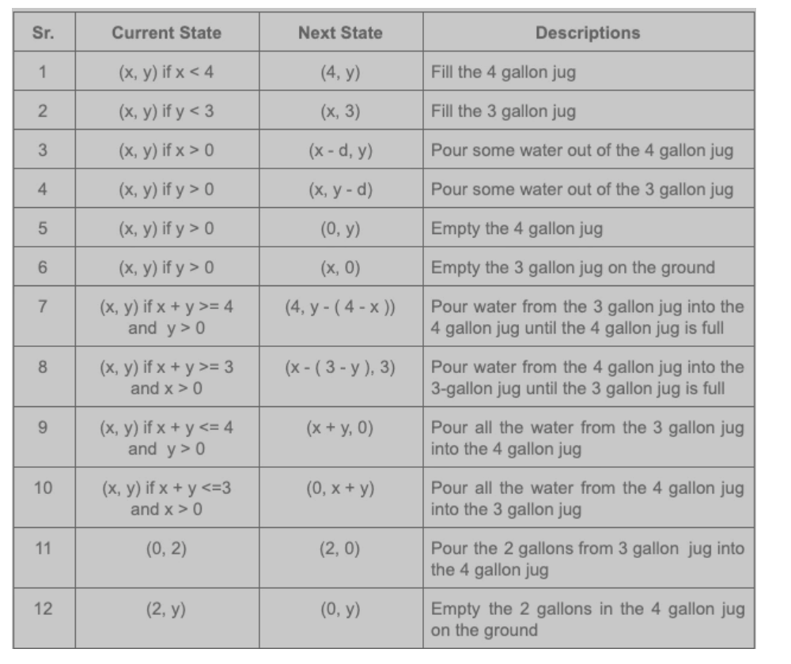

Input : 5,3

First jug with capacity 4

Explanation: The following steps are taken:

1. Fill the 5-liter jug completely.
2. Transfer 3 liters from a 5-liter jug to a 3-liter jug.
3. Empty the 3-liter capacity jug.
4. Transfer the remaining 2 liters from a 5-liter jug to a 3-liter jug.
5. Now, fill the 5-liter jug fully.
6. Pour 1 liter from a 5-liter jug into a 3-liter jug.
7. There! We have 4 liters in the first jug, now empty the 2nd jug.

